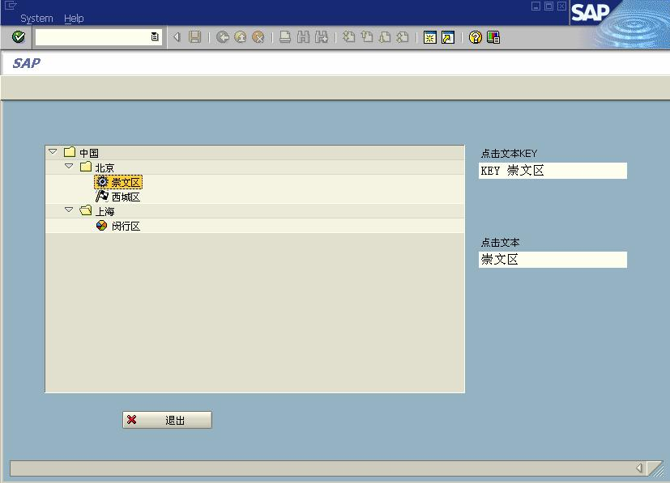
版权归原作者所有
仅供学习交流之用，请勿用于他途

第九章 Tree Control 的使用

Tree Control 是最常用的 Windows 控件之一，在其他语言中，称为“Tree View”等，ABAP
的 Tree Control 能完成相似的功能，本章主要介绍以下实例：
（1）实现一个简单的 Tree Control；
（2）建立有数据表接口的 Tree Control 对象；
（3）通过右键菜单完成 Tree Control 节点的增删修改等功能；
（4）Tree Control 对象与 ALV Grid 对象关联，实现在双击 Tree 节点时，变更 ALV Grid
的显示。
各例子简捷独立，先简单后复杂。

9.1 简单的 Tree Control 实例

如图 9-1 所示，本例将实现以下功能：
（1）建立一个以国家、城市、城区三层的 Tree Control 对象（固定数据）；
（2）当双击某个节点时，在文本框显示点的节点的 KEY 值和节点文本值。

图 9-1
实现步骤如下（前两步为基本功能，不再详细描述）：
（1）建立一个 ABAP 程序；
（2）使用屏幕制作器，建立 Screen。
 添加“定制控制”对象；

1

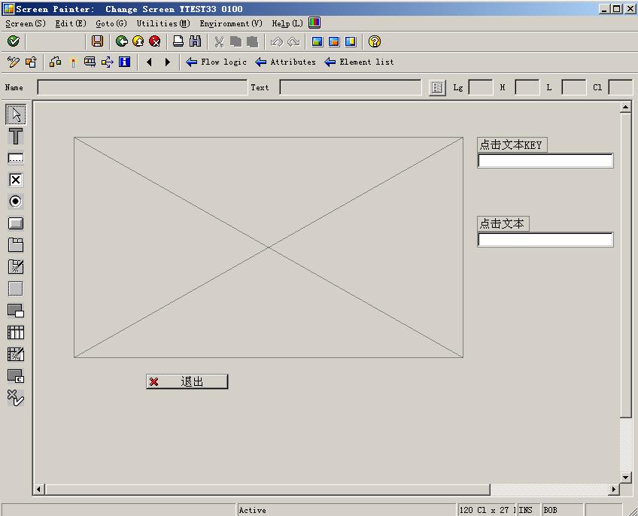
版权归原作者所有
仅供学习交流之用，请勿用于他途

 添加两个文本框，存放节点 KEY 值和节点文本值。
（3）建立程序。
 处理窗口调用，退出等基本功能；
 创建窗口定制对象，Tree Control 对象，测试运行时能看到 TREE 区域
 实现 Tree 节点的创建，测试运行，能看到 Tree 的所有节点；
 定义对象，建立双击方法，并将双击方法分配 Tree 对象，实现双击事件。
建立好的屏幕和对象界面如图 9-2 所示。

图 9-2
元素清单如图 9-3 所示。

2

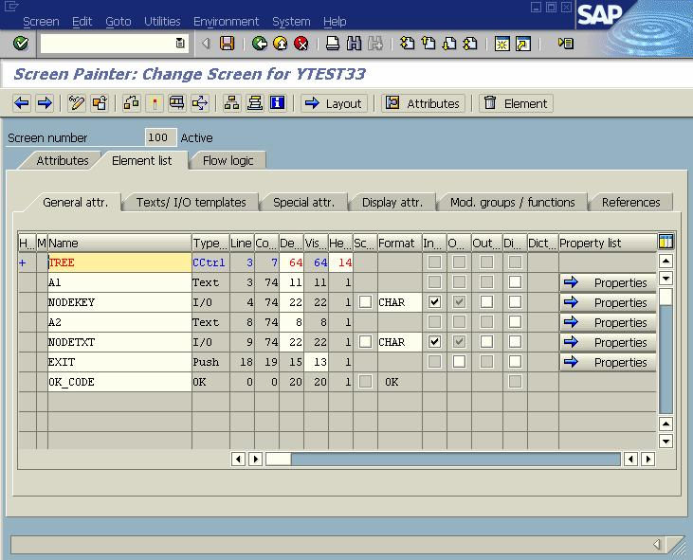
版权归原作者所有

逻辑流程序：
*PBO显示屏幕前的处理
PROCESS BEFORE OUTPUT.
MODULE STATUS_0100.
*PAI用户输入后的处理
PROCESS AFTER INPUT.
MODULE USER_COMMAND_0100.

主程序：
REPORT YTEST33.
*功能码返回值
DATA: OK_CODE TYPE SY-UCOMM,
SAVE_OK TYPE SY-UCOMM.
*定制对象

图 9-3
仅供学习交流之用，请勿用于他途

DATA: WA_CONTAINER TYPE SCRFNAME VALUE 'TREE',
*客户对象
WA_CUSTOM_CONTAINER TYPE REF TO CL_GUI_CUSTOM_CONTAINER,
WA_TREE TYPE REF TO CL_GUI_SIMPLE_TREE.
*NODE 节点表
DATA: NODE_TABLE LIKE TABLE OF MTREESNODE,
*节点

3

版权归原作者所有

NODE1 TYPE MTREESNODE.
*定义内表，变量需要传递，不加HEADER LINE
DATA WA_SPFLI TYPE TABLE OF SPFLI.
*当双击时取得节点KEY值与节点文本值变量
仅供学习交流之用，请勿用于他途

DATA: NODEKEY(200) VALUE 'NODE',NODETEXT(200) VALUE 'NONE'.

*定义对象，定义对象的双击方法，用于将该对象双击方法分配到树双击事件
CLASS LCL_APPLICATION DEFINITION DEFERRED.

*---------------------------------------------------------------------*
* CLASS lcl_application DEFINITION
*---------------------------------------------------------------------*
* 对象定义
*---------------------------------------------------------------------*
CLASS LCL_APPLICATION DEFINITION.
PUBLIC SECTION.
*自定义双击方法，参数为节点关键字
METHODS HANDLE_NODE_DOUBLE_CLICK
FOR EVENT NODE_DOUBLE_CLICK
OF CL_GUI_SIMPLE_TREE
IMPORTING NODE_KEY.
ENDCLASS. "

*---------------------------------------------------------------------*
* CLASS lcl_application IMPLEMENTATION
*---------------------------------------------------------------------*
* 对象方法实现
*---------------------------------------------------------------------*
CLASS LCL_APPLICATION IMPLEMENTATION.
METHOD HANDLE_NODE_DOUBLE_CLICK.
* 当双击时弹出信息窗口，调试用
* MESSAGE I208(00) WITH 'double'.
*取得KEY值，在窗口显示
NODEKEY = NODE_KEY.
*从节点内表中按关键字读取单个节点
READ TABLE NODE_TABLE WITH KEY NODE_KEY = NODE_KEY INTO NODE1.
*将节点文本在窗口中显示
NODETEXT = NODE1-TEXT.
ENDMETHOD. "HANDLE_NODE_DOUBLE_CLICK
ENDCLASS. "lcl_application IMPLEMENTATION

*自定义定义对象实例
DATA: G_APPLICATION TYPE REF TO LCL_APPLICATION.

4

版权归原作者所有

START-OF-SELECTION.

CREATE OBJECT G_APPLICATION.
* 直接调用窗口，在窗口PBO分配双击对象
CALL SCREEN 100.
仅供学习交流之用，请勿用于他途

*&---------------------------------------------------------------------*
*& Module STATUS_0100 OUTPUT
*&---------------------------------------------------------------------*
* text
*----------------------------------------------------------------------*
MODULE STATUS_0100 OUTPUT.
* SET PF-STATUS 'STATUS1'.
IF WA_CUSTOM_CONTAINER IS INITIAL.
PERFORM CREATE_TREE.
ENDIF.

ENDMODULE. " STATUS_0100 OUTPUT
*&---------------------------------------------------------------------*
*& Module USER_COMMAND_0100 INPUT
*&---------------------------------------------------------------------*
* 用户交互
*----------------------------------------------------------------------*
MODULE USER_COMMAND_0100 INPUT.
SAVE_OK = OK_CODE.
CLEAR OK_CODE.
CASE SAVE_OK.
WHEN 'EXIT'.
LEAVE PROGRAM.
ENDCASE.
ENDMODULE. " USER_COMMAND_0100 INPUT
*&---------------------------------------------------------------------*
*& Form CREATE_TREE
*&---------------------------------------------------------------------*
* 创建树及子节点
*----------------------------------------------------------------------*
* --> p1 text
* <-- p2 text
*----------------------------------------------------------------------*
FORM CREATE_TREE .
*事件内表及单个事件对象
DATA: EVENTS TYPE CNTL_SIMPLE_EVENTS,
EVENT1 TYPE CNTL_SIMPLE_EVENT.
*建立定制控制对象

5

版权归原作者所有

CREATE OBJECT WA_CUSTOM_CONTAINER
EXPORTING
CONTAINER_NAME = WA_CONTAINER.
*建立树对象
CREATE OBJECT WA_TREE
EXPORTING
* LIFETIME =
仅供学习交流之用，请勿用于他途

PARENT = WA_CUSTOM_CONTAINER
* SHELLSYLE =
NODE_SELECTION_MODE = CL_GUI_SIMPLE_TREE=>NODE_SEL_MODE_SINGLE
* HIDE_SELECTION =
* NAME =
* EXCEPTIONS
* LIFETIME_ERROR = 1
* CNTL_SYSTEM_ERROR = 2
* CREATE_ERROR = 3
* FAILED = 4
* ILLEGAL_NOCE_SELECTION_MODE = 5
* OTHERS = 6
.
IF SY-SUBRC <> 0.
* MESSAGE ID SY-MSGID TYPE SY-MSGTY NUMBER SY-MSGNO
* WITH SY-MSGV1 SY-MSGV2 SY-MSGV3 SY-MSGV4.
ENDIF.
*开始建立以国家-> 城市->城区 三层 的树
CLEAR NODE1.
*节点关键字
NODE1-NODE_KEY = '国家'.
*第一层
CLEAR NODE1-RELATKEY.
CLEAR NODE1-RELATSHIP.
*是文件夹
NODE1-HIDDEN = ''.
NODE1-DISABLED = ''.
NODE1-ISFOLDER = 'X'.
*不带ICON
CLEAR NODE1-N_IMAGE.
CLEAR NODE1-EXP_IMAGE.
CLEAR NODE1-EXPANDER.

NODE1-TEXT = '中国'.
APPEND NODE1 TO NODE_TABLE.
*二层节点
CLEAR NODE1.

6

版权归原作者所有

NODE1-NODE_KEY = '城市北京'.
*上层关系
NODE1-RELATKEY = '国家'.
仅供学习交流之用，请勿用于他途

NODE1-RELATSHIP = CL_GUI_SIMPLE_TREE=>RELAT_LAST_CHILD.
NODE1-HIDDEN = ''.
NODE1-DISABLED = ''.
NODE1-ISFOLDER = 'X'.
CLEAR NODE1-N_IMAGE.
CLEAR NODE1-EXP_IMAGE.
CLEAR NODE1-EXPANDER.
NODE1-TEXT = '北京'.
APPEND NODE1 TO NODE_TABLE.

CLEAR NODE1.

NODE1-NODE_KEY = '城市上海'.
NODE1-RELATKEY = '国家'.
NODE1-RELATSHIP = CL_GUI_SIMPLE_TREE=>RELAT_LAST_CHILD.
NODE1-HIDDEN = ''.
NODE1-DISABLED = ''.
NODE1-ISFOLDER = 'X'.
CLEAR NODE1-N_IMAGE.
CLEAR NODE1-EXP_IMAGE.
CLEAR NODE1-EXPANDER.
NODE1-TEXT = '上海'.
APPEND NODE1 TO NODE_TABLE.

CLEAR NODE1.
NODE1-NODE_KEY = 'KEY 崇文区'.
NODE1-RELATKEY = '城市北京'.
NODE1-RELATSHIP = CL_GUI_SIMPLE_TREE=>RELAT_LAST_CHILD.
NODE1-HIDDEN = ''.
NODE1-DISABLED = ''.
NODE1-ISFOLDER = ''.
*图标，可运行SHOWICON查阅
NODE1-N_IMAGE = '@9Y@'.
NODE1-EXP_IMAGE = '@9Y@'.
CLEAR NODE1-EXPANDER.
NODE1-TEXT = '崇文区'.
APPEND NODE1 TO NODE_TABLE.

CLEAR NODE1.
NODE1-NODE_KEY = 'KEY 西城区'.

7

版权归原作者所有

NODE1-RELATKEY = '城市北京'.
仅供学习交流之用，请勿用于他途

NODE1-RELATSHIP = CL_GUI_SIMPLE_TREE=>RELAT_LAST_CHILD.
NODE1-HIDDEN = ''.
NODE1-DISABLED = ''.
NODE1-ISFOLDER = ''.
NODE1-N_IMAGE = '@DF@'.
NODE1-EXP_IMAGE = '@DF@'.
CLEAR NODE1-EXPANDER.
NODE1-TEXT = '西城区'.
APPEND NODE1 TO NODE_TABLE.

CLEAR NODE1.
NODE1-NODE_KEY = 'KEY 闵行区'.
NODE1-RELATKEY = '城市上海'.
NODE1-RELATSHIP = CL_GUI_SIMPLE_TREE=>RELAT_LAST_CHILD.
NODE1-HIDDEN = ''.
NODE1-DISABLED = ''.
NODE1-ISFOLDER = ''.
NODE1-N_IMAGE = '@NL@'.
NODE1-EXP_IMAGE = '@NL@'.
CLEAR NODE1-EXPANDER.
NODE1-TEXT = '闵行区'.
APPEND NODE1 TO NODE_TABLE.
*按照节点内容添加节点
CALL METHOD WA_TREE->ADD_NODES
EXPORTING
TABLE_STRUCTURE_NAME = 'MTREESNODE'
NODE_TABLE = NODE_TABLE
* EXCEPTIONS
* ERROR_IN_NODE_TABLE = 1
* FAILED = 2
* DP_ERROF = 3
* TABLE_STRUCTURE_NAME_NOT_FOUND = 4
* OTHERS = 5
.
IF SY-SUBRC <> 0.
* MESSAGE ID SY-MSGID TYPE SY-MSGTY NUMBER SY-MSGNO
* WITH SY-MSGV1 SY-MSGV2 SY-MSGV3 SY-MSGV4.
ENDIF.
*定义双击事件
EVENT1-EVENTID = CL_GUI_SIMPLE_TREE=>EVENTID_NODE_DOUBLE_CLICK.
EVENT1-APPL_EVENT = 'X'.
APPEND EVENT1 TO EVENTS.
*添加事件内表

8

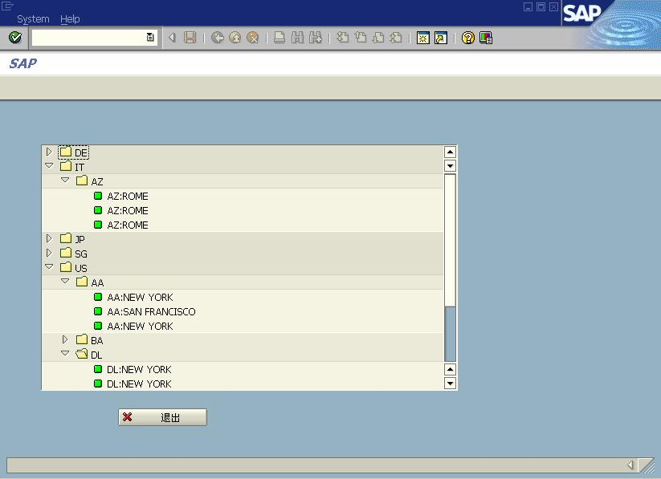
版权归原作者所有

CALL METHOD WA_TREE->SET_REGISTERED_EVENTS
EXPORTING
EVENTS = EVENTS
* EXCEPTIONS
* CNTL_ERROR = 1
* CNTL_SYSTEM_ERROR = 2
* ILLEGAL_EVENT_COMBINATION = 3
* OTHERS = 4
.
IF SY-SUBRC <> 0.
仅供学习交流之用，请勿用于他途

* MESSAGE ID SY-MSGID TYPE SY-MSGTY NUMBER SY-MSGNO
* WITH SY-MSGV1 SY-MSGV2 SY-MSGV3 SY-MSGV4.
ENDIF.
*将已定义的双击事件分配至树对象
SET HANDLER G_APPLICATION->HANDLE_NODE_DOUBLE_CLICK FOR WA_TREE.
ENDFORM. " CREATE_TREE

9.2 建立有数据表接口的 Tree Control 对象

先从数据表读取结构，并按照数据关系建立 Tree Control，如图 9-4 所示。

图 9-4

以航班表为例，以“起飞国家—>航班承运人—>航班连接”三层组成。
主程序：

9

版权归原作者所有

REPORT YTEST34 .
*功能码返回值
DATA: OK_CODE TYPE SY-UCOMM,
SAVE_OK TYPE SY-UCOMM.
*定制对象
仅供学习交流之用，请勿用于他途

DATA: WA_CONTAINER TYPE SCRFNAME VALUE 'TREE',
*客户对象
WA_CUSTOM_CONTAINER TYPE REF TO CL_GUI_CUSTOM_CONTAINER,
WA_TREE TYPE REF TO CL_GUI_SIMPLE_TREE.
*NODE 节点表
DATA: NODE_TABLE LIKE TABLE OF MTREESNODE,
*节点
NODE1 TYPE MTREESNODE.

DATA WA_SPFLI TYPE TABLE OF SPFLI WITH HEADER LINE.

START-OF-SELECTION.
SELECT * INTO TABLE WA_SPFLI FROM SPFLI
ORDER BY COUNTRYFR CARRID CONNID ASCENDING.

SET SCREEN 100.
*&---------------------------------------------------------------------*
*& Module STATUS_0100 OUTPUT
*&---------------------------------------------------------------------*
* text
*----------------------------------------------------------------------*
MODULE STATUS_0100 OUTPUT.
* SET PF-STATUS 'STATUS1'.
* CLEAR WA_CUSTOM_CONTAINER.
IF WA_CUSTOM_CONTAINER IS INITIAL.
PERFORM CREATE_TREE.
ENDIF.

ENDMODULE. " STATUS_0100 OUTPUT
*&---------------------------------------------------------------------*
*& Module USER_COMMAND_0100 INPUT
*&---------------------------------------------------------------------*
* 用户交互
*----------------------------------------------------------------------*
MODULE USER_COMMAND_0100 INPUT.
SAVE_OK = OK_CODE.
CLEAR OK_CODE.
CASE SAVE_OK.
WHEN 'EXIT'.

10

版权归原作者所有

* LEAVE PROGRAM.
LEAVE TO SCREEN 0.
ENDCASE.
仅供学习交流之用，请勿用于他途

ENDMODULE. " USER_COMMAND_0100 INPUT
*&---------------------------------------------------------------------*
*& Form CREATE_TREE
*&---------------------------------------------------------------------*
* 创建树及子节点
*----------------------------------------------------------------------*
* --> p1 text
* <-- p2 text
*----------------------------------------------------------------------*
FORM CREATE_TREE .
*建立定制控制对象
CREATE OBJECT WA_CUSTOM_CONTAINER
EXPORTING
CONTAINER_NAME = WA_CONTAINER.
*建立树对象
CREATE OBJECT WA_TREE
EXPORTING
* LIFETIME =
PARENT = WA_CUSTOM_CONTAINER
* SHELLSYLE =
NODE_SELECTION_MODE = CL_GUI_SIMPLE_TREE=>NODE_SEL_MODE_SINGLE
* HIDE_SELECTION =
* NAME =
* EXCEPTIONS
* LIFETIME_ERROR = 1
* CNTL_SYSTEM_ERROR = 2
* CREATE_ERROR = 3
* FAILED = 4
* ILLEGAL_NOCE_SELECTION_MODE = 5
* OTHERS = 6
.
IF SY-SUBRC <> 0.
* MESSAGE ID SY-MSGID TYPE SY-MSGTY NUMBER SY-MSGNO
* WITH SY-MSGV1 SY-MSGV2 SY-MSGV3 SY-MSGV4.
ENDIF.
DATA: COUNTRYFR LIKE SPFLI-COUNTRYFR,
CARRID LIKE SPFLI-CARRID.

DATA: STR1(255).

LOOP AT WA_SPFLI.

11

版权归原作者所有

IF COUNTRYFR NE WA_SPFLI-COUNTRYFR.
CLEAR NODE1.
NODE1-NODE_KEY = WA_SPFLI-COUNTRYFR.
*第一层
CLEAR NODE1-RELATKEY.
CLEAR NODE1-RELATSHIP.
*是文件夹
NODE1-HIDDEN = ''.
NODE1-DISABLED = ''.
NODE1-ISFOLDER = 'X'.
*不带ICON
CLEAR NODE1-N_IMAGE.
CLEAR NODE1-EXP_IMAGE.
CLEAR NODE1-EXPANDER.

NODE1-TEXT = WA_SPFLI-COUNTRYFR.
APPEND NODE1 TO NODE_TABLE.
ENDIF.

IF ( COUNTRYFR NE WA_SPFLI-COUNTRYFR ) OR
( CARRID <> WA_SPFLI-CARRID ).
CLEAR NODE1.
仅供学习交流之用，请勿用于他途

CONCATENATE WA_SPFLI-COUNTRYFR WA_SPFLI-CARRID
INTO NODE1-NODE_KEY.
*上层关系
NODE1-RELATKEY = WA_SPFLI-COUNTRYFR.
NODE1-RELATSHIP = CL_GUI_SIMPLE_TREE=>RELAT_LAST_CHILD.
NODE1-HIDDEN = ''.
NODE1-DISABLED = ''.
NODE1-ISFOLDER = 'X'.
CLEAR NODE1-N_IMAGE.
CLEAR NODE1-EXP_IMAGE.
CLEAR NODE1-EXPANDER.
*节点显示CARRID
NODE1-TEXT = WA_SPFLI-CARRID.
APPEND NODE1 TO NODE_TABLE.
ENDIF.

COUNTRYFR = WA_SPFLI-COUNTRYFR.
CARRID = WA_SPFLI-CARRID.
CLEAR NODE1.
CONCATENATE WA_SPFLI-COUNTRYFR WA_SPFLI-CARRID
WA_SPFLI-CONNID INTO NODE1-NODE_KEY.

12

版权归原作者所有
仅供学习交流之用，请勿用于他途

CONCATENATE WA_SPFLI-COUNTRYFR WA_SPFLI-CARRID
INTO STR1.
NODE1-RELATKEY = STR1.
NODE1-RELATSHIP = CL_GUI_SIMPLE_TREE=>RELAT_LAST_CHILD.
NODE1-HIDDEN = ''.
NODE1-DISABLED = ''.
NODE1-ISFOLDER = 'X'.
NODE1-N_IMAGE = '@5B@'.
NODE1-EXP_IMAGE = '@5B@'.
CLEAR NODE1-EXPANDER.
CONCATENATE WA_SPFLI-CARRID ':' WA_SPFLI-CITYFROM
INTO STR1.
NODE1-TEXT = STR1.
APPEND NODE1 TO NODE_TABLE.
ENDLOOP.

*按照节点内容添加节点
CALL METHOD WA_TREE->ADD_NODES
EXPORTING
TABLE_STRUCTURE_NAME = 'MTREESNODE'
NODE_TABLE = NODE_TABLE
* EXCEPTIONS
* ERROR_IN_NODE_TABLE = 1
* FAILED = 2
* DP_ERROF = 3
* TABLE_STRUCTURE_NAME_NOT_FOUND = 4
* OTHERS = 5
.
IF SY-SUBRC <> 0.
* MESSAGE ID SY-MSGID TYPE SY-MSGTY NUMBER SY-MSGNO
* WITH SY-MSGV1 SY-MSGV2 SY-MSGV3 SY-MSGV4.
ENDIF.
ENDFORM. " CREATE_TREE

9.3 通过右键菜单完成 Tree Control 节点的增删改功能

Tree 节点的增删改是很重要的功能，包括：增加本级节点，增加子节点，修改节点，删
除节点。完成后效果如下：
选择根节点，单击右键，弹出右键菜单，如选择“北京”节点，选择“增加本级节点”
菜单，如图 9-5 所示。

13

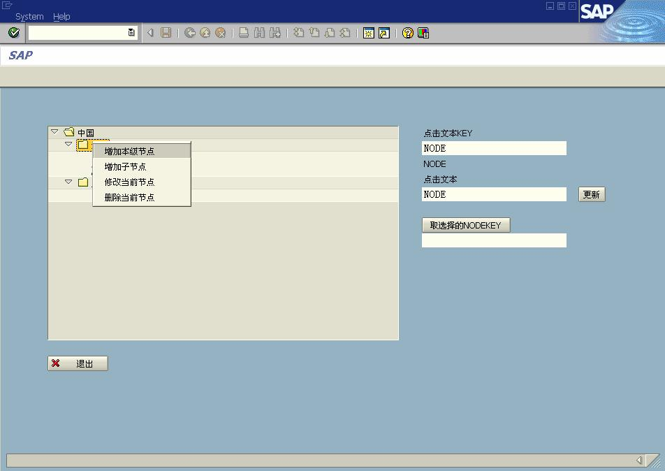
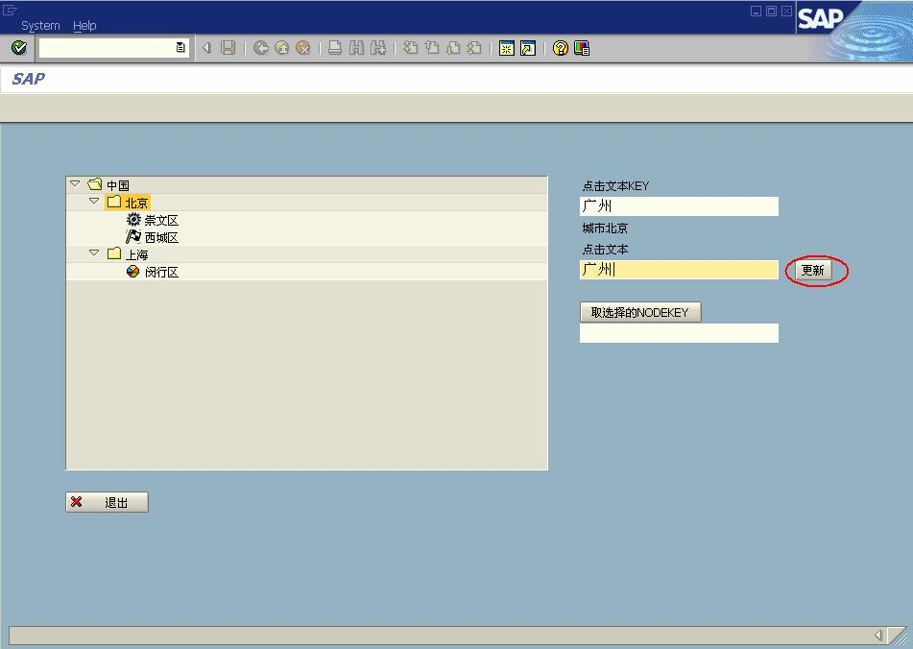
版权归原作者所有

图 9-5
仅供学习交流之用，请勿用于他途

在单击文本输入“广州”后，单击“更新”按钮，如图 9-6 所示。

图 9-6
Tree 对象增加了“广州”节点，选择该节点，选右键菜单中“增加子节点”菜单，如图
9-7 所示。

14

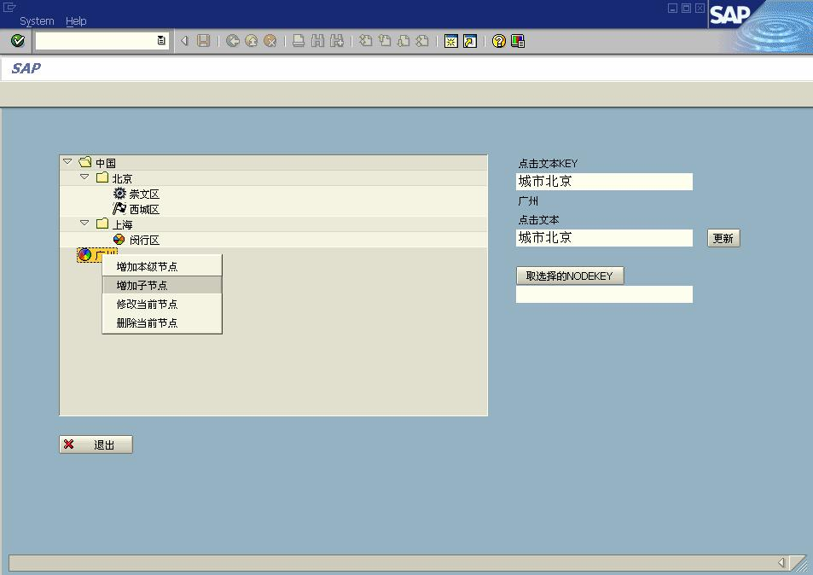
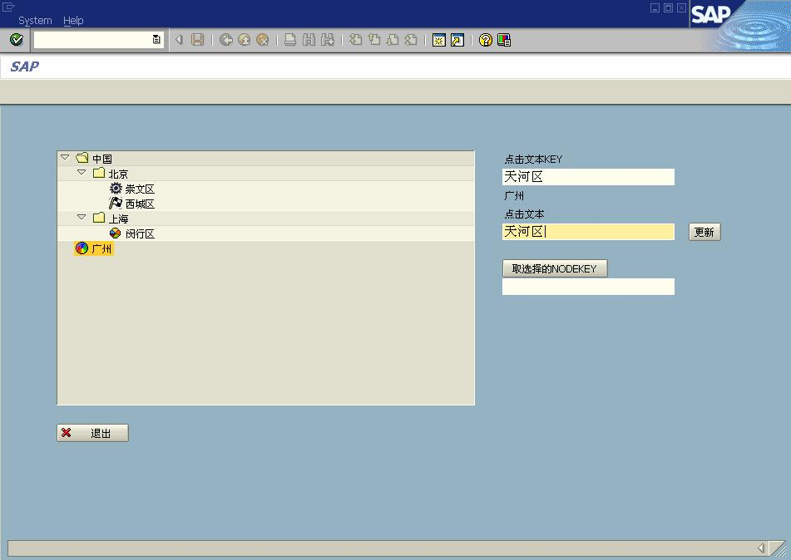
版权归原作者所有

图 9-7
仅供学习交流之用，请勿用于他途

输入“天河区”，单击“更新”按钮，如图 9-8 所示。

图 9-8
增加节点后，输出结果如图 9-9 所示。

15

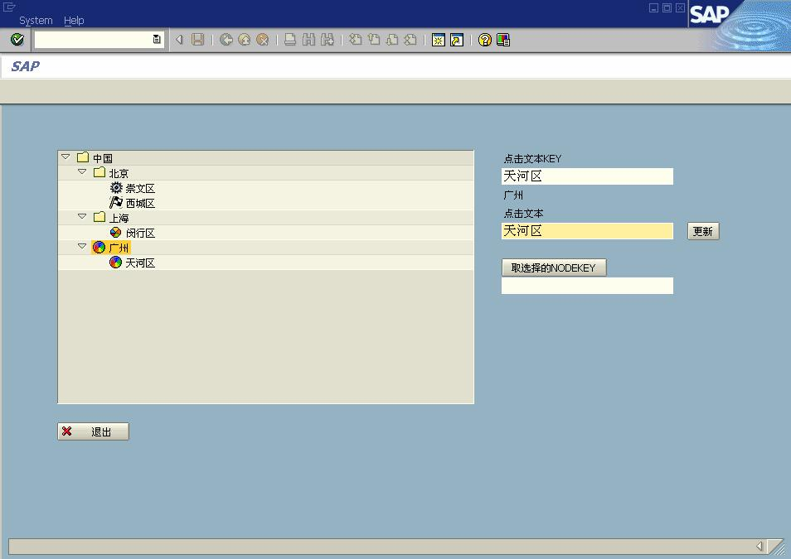
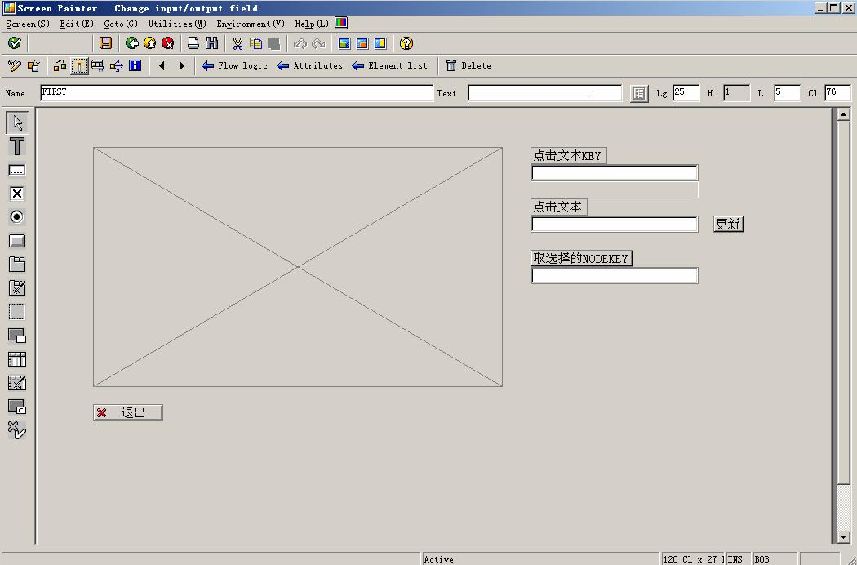
版权归原作者所有

图 9-9
仅供学习交流之用，请勿用于他途

除上述功能外，还有修改及删除节点等功能。
设计 Screen 界面如图 9-10 所示。

图 9-10
主程序：
REPORT YTEST35.
DATA: OK_CODE TYPE SY-UCOMM,

16

版权归原作者所有

SAVE_OK TYPE SY-UCOMM.
仅供学习交流之用，请勿用于他途

DATA: WA_CONTAINER TYPE SCRFNAME VALUE 'TREE1',
WA_CUSTOM_CONTAINER TYPE REF TO CL_GUI_CUSTOM_CONTAINER,
WA_TREE TYPE REF TO CL_GUI_SIMPLE_TREE.

DATA: NODE_TABLE LIKE TABLE OF MTREESNODE,
ANODE_TABLE LIKE TABLE OF MTREESNODE,
NODE1 TYPE MTREESNODE,
NODE2 TYPE MTREESNODE.

DATA WA_SPFLI TYPE TABLE OF SPFLI.

DATA: NODEKEY(200) VALUE 'NODE',
NODETEXT(200) VALUE 'NODE',
NODEKEYOLD(200) VALUE 'NODE',
GETKEY(200).
DATA MENUSTR(10) VALUE ''.
CLASS LCL_APPLICATION DEFINITION DEFERRED.

*---------------------------------------------------------------------*
* CLASS lcl_application DEFINITION
*---------------------------------------------------------------------*
*
*---------------------------------------------------------------------*
CLASS LCL_APPLICATION DEFINITION.
PUBLIC SECTION.
METHODS: HANDLE_NODE_DOUBLE_CLICK
FOR EVENT NODE_DOUBLE_CLICK
OF CL_GUI_SIMPLE_TREE
IMPORTING NODE_KEY.
METHODS:
HANDLE_NODE_CONTEXT_MENU_REQ
FOR EVENT NODE_CONTEXT_MENU_REQUEST
OF CL_GUI_SIMPLE_TREE
IMPORTING NODE_KEY MENU,
HANDLE_NODE_CONTEXT_MENU_SEL
FOR EVENT NODE_CONTEXT_MENU_SELECT
OF CL_GUI_SIMPLE_TREE
IMPORTING NODE_KEY FCODE.

ENDCLASS. "LCL_APPLICATION DEFINITION

*---------------------------------------------------------------------*

17

版权归原作者所有

* CLASS lcl_application IMPLEMENTATION
仅供学习交流之用，请勿用于他途

*---------------------------------------------------------------------*
*
*---------------------------------------------------------------------*
CLASS LCL_APPLICATION IMPLEMENTATION.
METHOD HANDLE_NODE_DOUBLE_CLICK.
NODEKEY = NODE_KEY.
READ TABLE NODE_TABLE WITH KEY NODE_KEY = NODE_KEY INTO NODE1.
NODETEXT = NODE1-TEXT.
ENDMETHOD. "HANDLE_NODE_DOUBLE_CLICK

METHOD HANDLE_NODE_CONTEXT_MENU_REQ.
CALL METHOD MENU->ADD_FUNCTION
EXPORTING
TEXT = '增加本级节点'
FCODE = 'CODE1'.

CALL METHOD MENU->ADD_FUNCTION
EXPORTING
TEXT = '增加子节点'
FCODE = 'CODE2'.

CALL METHOD MENU->ADD_FUNCTION
EXPORTING
TEXT = '修改当前节点'
FCODE = 'CODE3'.
CALL METHOD MENU->ADD_FUNCTION
EXPORTING
TEXT = '删除当前节点'
FCODE = 'CODE4'.
ENDMETHOD. "handle_node_context_menu_req

METHOD HANDLE_NODE_CONTEXT_MENU_SEL.
DATA STR1 TYPE TV_NODEKEY.
CALL METHOD WA_TREE->GET_SELECTED_NODE
IMPORTING
NODE_KEY = STR1.
IF SY-SUBRC = 0.
MENUSTR = FCODE.
NODEKEY = STR1.
NODEKEYOLD = STR1.

READ TABLE NODE_TABLE WITH KEY NODE_KEY = STR1 INTO NODE1.
NODETEXT = NODE1-TEXT.

18

版权归原作者所有

IF FCODE = 'CODE4'.
CALL METHOD WA_TREE->DELETE_NODE
EXPORTING
NODE_KEY = NODE1-NODE_KEY.
仅供学习交流之用，请勿用于他途

DELETE NODE_TABLE WHERE NODE_KEY = NODEKEY.
ENDIF.
ENDIF.
ENDMETHOD. "handle_node_context_menu_sel
ENDCLASS. "lcl_application IMPLEMENTATION

*自定义定义对象实例
DATA: G_APPLICATION TYPE REF TO LCL_APPLICATION.

START-OF-SELECTION.
CALL SCREEN 100.
*&---------------------------------------------------------------------*
*& Module STATUS_0100 OUTPUT
*&---------------------------------------------------------------------*
* text
*----------------------------------------------------------------------*
MODULE STATUS_0100 OUTPUT.
* SET PF-STATUS 'xxxxxxxx'.
* SET TITLEBAR 'xxx'.
IF WA_CUSTOM_CONTAINER IS INITIAL.
CREATE OBJECT G_APPLICATION.
PERFORM CREATE_TREE.
ENDIF.
ENDMODULE. " STATUS_0100 OUTPUT
*&---------------------------------------------------------------------*
*& Module USER_COMMAND_0100 INPUT
*&---------------------------------------------------------------------*
* text
*----------------------------------------------------------------------*
MODULE USER_COMMAND_0100 INPUT.
DATA STR1 TYPE TV_NODEKEY.
SAVE_OK = OK_CODE.
CLEAR OK_CODE.

CASE SAVE_OK.
WHEN 'EXIT'.
LEAVE PROGRAM.
WHEN 'GETKEY'.
CALL METHOD WA_TREE->GET_SELECTED_NODE

19

版权归原作者所有

IMPORTING
NODE_KEY = STR1.

IF SY-SUBRC EQ 0.
GETKEY = STR1.
ENDIF.
WHEN 'UPTREE'.
仅供学习交流之用，请勿用于他途

IF ( MENUSTR = 'CODE1' ) OR ( MENUSTR = 'CODE2').
READ TABLE NODE_TABLE
WITH KEY NODE_KEY = NODEKEY INTO NODE1.
IF SY-SUBRC EQ 0.
MESSAGE E208(00) WITH '键值重复！'.
ENDIF.
ENDIF.

CASE MENUSTR.
WHEN 'CODE1'.
READ TABLE NODE_TABLE WITH KEY NODE_KEY = NODEKEYOLD
INTO NODE2.

CLEAR NODE1.
NODE1-NODE_KEY = NODEKEY.
NODE1-RELATKEY = NODE2-RELATKEY.
NODE1-RELATSHIP = CL_GUI_SIMPLE_TREE=>RELAT_LAST_CHILD.
NODE1-HIDDEN = ''.
NODE1-DISABLED = ''.
NODE1-ISFOLDER = 'X'.
NODE1-N_IMAGE = '@G3@'.
NODE1-EXP_IMAGE = '@G3@'.
CLEAR NODE1-EXPANDER.
NODE1-TEXT = NODETEXT.
APPEND NODE1 TO NODE_TABLE.
CLEAR ANODE_TABLE.
APPEND NODE1 TO ANODE_TABLE.

CALL METHOD WA_TREE->ADD_NODES
EXPORTING
TABLE_STRUCTURE_NAME = 'MTREESNODE'
NODE_TABLE = ANODE_TABLE.
IF SY-SUBRC <> 0.
* MESSAGE ID SY-MSGID TYPE SY-MSGTY NUMBER SY-MSGNO
* WITH SY-MSGV1 SY-MSGV2 SY-MSGV3 SY-MSGV4.
ENDIF.

20

版权归原作者所有

WHEN 'CODE2'.
CLEAR NODE1.
NODE1-NODE_KEY = NODEKEY.
NODE1-RELATKEY = NODEKEYOLD..
仅供学习交流之用，请勿用于他途

NODE1-RELATSHIP = CL_GUI_SIMPLE_TREE=>RELAT_LAST_CHILD.
NODE1-HIDDEN = ''.
NODE1-DISABLED = ''.
NODE1-ISFOLDER = 'X'.
NODE1-N_IMAGE = '@G3@'.
NODE1-EXP_IMAGE = '@G3@'.
CLEAR NODE1-EXPANDER.
NODE1-TEXT = NODETEXT.
APPEND NODE1 TO NODE_TABLE.
CLEAR ANODE_TABLE.
APPEND NODE1 TO ANODE_TABLE.

CALL METHOD WA_TREE->ADD_NODES
EXPORTING
TABLE_STRUCTURE_NAME = 'MTREESNODE'
NODE_TABLE = ANODE_TABLE.
IF SY-SUBRC <> 0.
* MESSAGE ID SY-MSGID TYPE SY-MSGTY NUMBER SY-MSGNO
* WITH SY-MSGV1 SY-MSGV2 SY-MSGV3 SY-MSGV4.
ENDIF.

WHEN 'CODE3'.
NODE1-NODE_KEY = NODEKEYOLD.
CALL METHOD WA_TREE->NODE_SET_TEXT
EXPORTING
NODE_KEY = NODE1-NODE_KEY
TEXT = NODETEXT.
IF SY-SUBRC <> 0.
* MESSAGE ID SY-MSGID TYPE SY-MSGTY NUMBER SY-MSGNO
* WITH SY-MSGV1 SY-MSGV2 SY-MSGV3 SY-MSGV4.
ENDIF.

ENDCASE.
ENDCASE.
ENDMODULE. " USER_COMMAND_0100 INPUT
*&---------------------------------------------------------------------*
*& Form CREATE_TREE
*&---------------------------------------------------------------------*
* text
*----------------------------------------------------------------------*

21

版权归原作者所有

* --> p1 text
* <-- p2 text
仅供学习交流之用，请勿用于他途

*----------------------------------------------------------------------*
FORM CREATE_TREE .
DATA: EVENTS TYPE CNTL_SIMPLE_EVENTS,
EVENT1 TYPE CNTL_SIMPLE_EVENT.

CREATE OBJECT WA_CUSTOM_CONTAINER
EXPORTING
CONTAINER_NAME = WA_CONTAINER.

CREATE OBJECT WA_TREE
EXPORTING
PARENT = WA_CUSTOM_CONTAINER
NODE_SELECTION_MODE = CL_GUI_SIMPLE_TREE=>NODE_SEL_MODE_SINGLE.
IF SY-SUBRC <> 0.
* MESSAGE ID SY-MSGID TYPE SY-MSGTY NUMBER SY-MSGNO
* WITH SY-MSGV1 SY-MSGV2 SY-MSGV3 SY-MSGV4.
ENDIF.

CLEAR NODE1.

NODE1-NODE_KEY = '国家'.
CLEAR NODE1-RELATKEY.
CLEAR NODE1-RELATSHIP.

NODE1-HIDDEN = ''.
NODE1-DISABLED = ''.
NODE1-ISFOLDER = 'X'.

CLEAR NODE1-N_IMAGE.
CLEAR NODE1-EXP_IMAGE.
CLEAR NODE1-EXPANDER.
NODE1-TEXT = '中国'.
APPEND NODE1 TO NODE_TABLE.

CLEAR NODE1.
NODE1-NODE_KEY = '城市北京'.
NODE1-RELATKEY = '国家'.
NODE1-RELATSHIP = CL_GUI_SIMPLE_TREE=>RELAT_LAST_CHILD.
NODE1-HIDDEN = ''.
NODE1-DISABLED = ''.
NODE1-ISFOLDER = 'X'.
CLEAR NODE1-N_IMAGE.

22

版权归原作者所有

CLEAR NODE1-EXP_IMAGE.
CLEAR NODE1-EXPANDER.
NODE1-TEXT = '北京'.
APPEND NODE1 TO NODE_TABLE.

CLEAR NODE1.
NODE1-NODE_KEY = '城市上海'.
NODE1-RELATKEY = '国家'.
仅供学习交流之用，请勿用于他途

NODE1-RELATSHIP = CL_GUI_SIMPLE_TREE=>RELAT_LAST_CHILD.
NODE1-HIDDEN = ''.
NODE1-DISABLED = ''.
NODE1-ISFOLDER = 'X'.
CLEAR NODE1-N_IMAGE.
CLEAR NODE1-EXP_IMAGE.
CLEAR NODE1-EXPANDER.
NODE1-TEXT = '上海'.
APPEND NODE1 TO NODE_TABLE.

CLEAR NODE1.
NODE1-NODE_KEY = 'KEY 崇文区'.
NODE1-RELATKEY = '城市北京'.
NODE1-RELATSHIP = CL_GUI_SIMPLE_TREE=>RELAT_LAST_CHILD.
NODE1-HIDDEN = ''.
NODE1-DISABLED = ''.
NODE1-ISFOLDER = ''.
*图标，可运行SHOWICON查阅
NODE1-N_IMAGE = '@9Y@'.
NODE1-EXP_IMAGE = '@9Y@'.
CLEAR NODE1-EXPANDER.
NODE1-TEXT = '崇文区'.
APPEND NODE1 TO NODE_TABLE.

CLEAR NODE1.
NODE1-NODE_KEY = 'KEY 西城区'.
NODE1-RELATKEY = '城市北京'.
NODE1-RELATSHIP = CL_GUI_SIMPLE_TREE=>RELAT_LAST_CHILD.
NODE1-HIDDEN = ''.
NODE1-DISABLED = ''.
NODE1-ISFOLDER = ''.
NODE1-N_IMAGE = '@DF@'.
NODE1-EXP_IMAGE = '@DF@'.
CLEAR NODE1-EXPANDER.
NODE1-TEXT = '西城区'.
APPEND NODE1 TO NODE_TABLE.

23

版权归原作者所有

CLEAR NODE1.
NODE1-NODE_KEY = 'KEY 闵行区'.
NODE1-RELATKEY = '城市上海'.
仅供学习交流之用，请勿用于他途

NODE1-RELATSHIP = CL_GUI_SIMPLE_TREE=>RELAT_LAST_CHILD.
NODE1-HIDDEN = ''.
NODE1-DISABLED = ''.
NODE1-ISFOLDER = ''.
NODE1-N_IMAGE = '@NL@'.
NODE1-EXP_IMAGE = '@NL@'.
CLEAR NODE1-EXPANDER.
NODE1-TEXT = '闵行区'.
APPEND NODE1 TO NODE_TABLE.

*按照节得内容掏加节得
CALL METHOD WA_TREE->ADD_NODES
EXPORTING
TABLE_STRUCTURE_NAME = 'MTREESNODE'
NODE_TABLE = NODE_TABLE
* EXCEPTIONS
* ERROR_IN_NODE_TABLE = 1
* FAILED = 2
* DP_ERROF = 3
* TABLE_STRUCTURE_NAME_NOT_FOUND = 4
* OTHERS = 5
.
IF SY-SUBRC <> 0.
* MESSAGE ID SY-MSGID TYPE SY-MSGTY NUMBER SY-MSGNO
* WITH SY-MSGV1 SY-MSGV2 SY-MSGV3 SY-MSGV4.
ENDIF.

CALL METHOD WA_TREE->EXPAND_NODE
EXPORTING
NODE_KEY = '国家'
EXPAND_SUBTREE = 'X'
EXCEPTIONS
FAILED = 1
ILLEGAL_LEVEL_COUNT = 2
CNTL_SYSTEM_ERROR = 3
NODE_NOT_FOUND = 4
CANNOT_EXPAND_LEAF = 5.
IF SY-SUBRC NE 0.

ENDIF.

24

版权归原作者所有

*定义双击事件
仅供学习交流之用，请勿用于他途

EVENT1-EVENTID = CL_GUI_SIMPLE_TREE=>EVENTID_NODE_DOUBLE_CLICK.
EVENT1-APPL_EVENT = 'X'.
APPEND EVENT1 TO EVENTS.

EVENT1-EVENTID = CL_GUI_SIMPLE_TREE=>EVENTID_NODE_CONTEXT_MENU_REQ.
EVENT1-APPL_EVENT = ''.
APPEND EVENT1 TO EVENTS.

CALL METHOD WA_TREE->SET_CTX_MENU_SELECT_EVENT_APPL
EXPORTING
APPL_EVENT = 'X'.

*添加事件内表
CALL METHOD WA_TREE->SET_REGISTERED_EVENTS
EXPORTING
EVENTS = EVENTS
* EXCEPTIONS
* CNTL_ERROR = 1
* CNTL_SYSTEM_ERROR = 2
* ILLEGAL_EVENT_COMBINATION = 3
* OTHERS = 4
.
IF SY-SUBRC <> 0.
* MESSAGE ID SY-MSGID TYPE SY-MSGTY NUMBER SY-MSGNO
* WITH SY-MSGV1 SY-MSGV2 SY-MSGV3 SY-MSGV4.
ENDIF.
*将已定义的双击事件分配至树对象
SET HANDLER G_APPLICATION->HANDLE_NODE_DOUBLE_CLICK FOR WA_TREE.

SET HANDLER G_APPLICATION->HANDLE_NODE_CONTEXT_MENU_REQ FOR WA_TREE.

SET HANDLER G_APPLICATION->HANDLE_NODE_CONTEXT_MENU_SEL FOR WA_TREE.
ENDFORM. " CREATE_TREE

9.4 Tree Control 对象与 ALV Grid 对象关联

在双击 Tree 对象时，变更 ALV Trid 对象的显示，实现界面如图 9-11 所示。

25

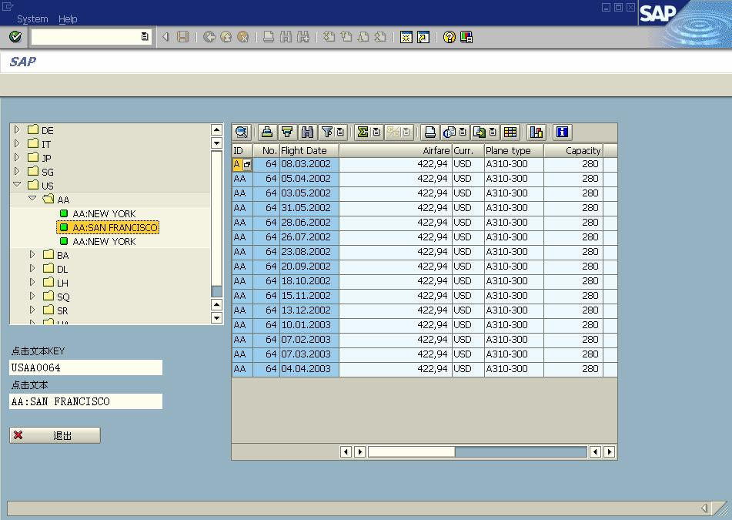
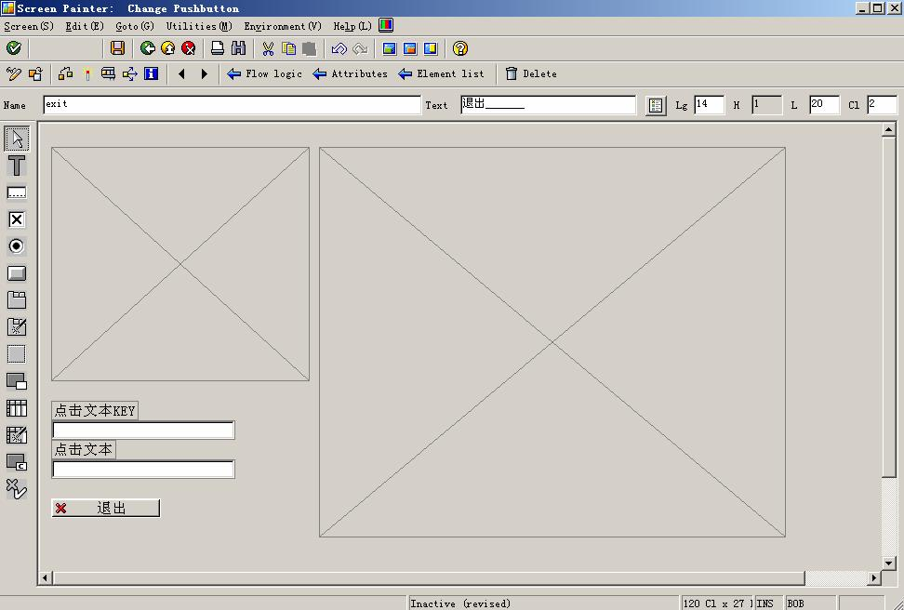
版权归原作者所有

Screen 设计界面如图 9-12 所示。

主程序：
REPORT YTEST36.
DATA: OK_CODE TYPE SY-UCOMM,
SAVE_OK TYPE SY-UCOMM.

图 9-11

图 9-12

26
仅供学习交流之用，请勿用于他途

版权归原作者所有
仅供学习交流之用，请勿用于他途

DATA: WA_CONTAINER TYPE SCRFNAME VALUE 'TREE1',
WA_CONTAINERALV TYPE SCRFNAME VALUE 'ALV1',
WA_CUSTOM_CONTAINER TYPE REF TO CL_GUI_CUSTOM_CONTAINER,
WA_CUSTOM_CONTAINERALV TYPE REF TO CL_GUI_CUSTOM_CONTAINER,
WA_TREE TYPE REF TO CL_GUI_SIMPLE_TREE,
WA_ALV TYPE REF TO CL_GUI_ALV_GRID.

DATA: NODE_TABLE LIKE TABLE OF MTREESNODE,
NODE1 TYPE MTREESNODE.

DATA WA_SPFLI TYPE TABLE OF SPFLI WITH HEADER LINE.
DATA WA_SFLIGHT TYPE TABLE OF SFLIGHT.

DATA: NODEKEY(200) VALUE 'NODE',
NODETEXT(200) VALUE 'NODE'.

CLASS LCL_APPLICATION DEFINITION DEFERRED.
DATA EVENT_RECEIVER TYPE REF TO LCL_APPLICATION.
*---------------------------------------------------------------------*
* CLASS lcl_application DEFINITION
*---------------------------------------------------------------------*
*
*---------------------------------------------------------------------*
CLASS LCL_APPLICATION DEFINITION.
PUBLIC SECTION.

METHODS HANDLE_NODE_DOUBLE_CLICK
FOR EVENT NODE_DOUBLE_CLICK
OF CL_GUI_SIMPLE_TREE
IMPORTING NODE_KEY.

ENDCLASS. "lcl_application DEFINITION
*---------------------------------------------------------------------*
* CLASS lcl_application IMPLEMENTATION
*---------------------------------------------------------------------*
*
*---------------------------------------------------------------------*
CLASS LCL_APPLICATION IMPLEMENTATION.
METHOD HANDLE_NODE_DOUBLE_CLICK.
NODEKEY = NODE_KEY.
READ TABLE NODE_TABLE WITH KEY NODE_KEY = NODE_KEY
INTO NODE1.
NODETEXT = NODE1-TEXT.

27

版权归原作者所有

CLEAR WA_SFLIGHT.
仅供学习交流之用，请勿用于他途

SELECT * INTO TABLE WA_SFLIGHT FROM SFLIGHT
WHERE CARRID = NODE1-NODE_KEY+2(2)
AND CONNID = NODE1-NODE_KEY+4(4).

* CREATE OBJECT WA_ALV
* EXPORTING I_PARENT = WA_CUSTOM_CONTAINER.

CALL METHOD WA_ALV->SET_TABLE_FOR_FIRST_DISPLAY
EXPORTING
I_STRUCTURE_NAME = 'SFLIGHT'
CHANGING
IT_OUTTAB = WA_SFLIGHT.
ENDMETHOD. "handle_node_double_click
ENDCLASS. "lcl_application IMPLEMENTATION

DATA G_APPLICATION TYPE REF TO LCL_APPLICATION.

START-OF-SELECTION.
SELECT * INTO TABLE WA_SPFLI FROM SPFLI
ORDER BY COUNTRYFR CARRID ASCENDING.
CREATE OBJECT G_APPLICATION.
SET SCREEN 100.
*&---------------------------------------------------------------------*
*& Module STATUS_0100 OUTPUT
*&---------------------------------------------------------------------*
* text
*----------------------------------------------------------------------*
MODULE STATUS_0100 OUTPUT.
* SET PF-STATUS 'xxxxxxxx'.
* SET TITLEBAR 'xxx'.
IF WA_CUSTOM_CONTAINER IS INITIAL.
PERFORM CREATE_TREE.
ENDIF.

ENDMODULE. " STATUS_0100 OUTPUT
*&---------------------------------------------------------------------*
*& Module USER_COMMAND_0100 INPUT
*&---------------------------------------------------------------------*
* text
*----------------------------------------------------------------------*
MODULE USER_COMMAND_0100 INPUT.
SAVE_OK = OK_CODE.

28

版权归原作者所有

CLEAR OK_CODE.
CASE SAVE_OK.
WHEN 'EXIT'.
LEAVE PROGRAM.
ENDCASE.
仅供学习交流之用，请勿用于他途

ENDMODULE. " USER_COMMAND_0100 INPUT
*&---------------------------------------------------------------------*
*& Form CREATE_TREE
*&---------------------------------------------------------------------*
* text
*----------------------------------------------------------------------*
* --> p1 text
* <-- p2 text
*----------------------------------------------------------------------*
FORM CREATE_TREE .
DATA: EVENTS TYPE CNTL_SIMPLE_EVENTS,
EVENT1 TYPE CNTL_SIMPLE_EVENT.
CREATE OBJECT WA_CUSTOM_CONTAINER
EXPORTING
CONTAINER_NAME = WA_CONTAINER.

CREATE OBJECT WA_CUSTOM_CONTAINERALV
EXPORTING
CONTAINER_NAME = WA_CONTAINERALV.

CREATE OBJECT WA_ALV
EXPORTING
I_PARENT = WA_CUSTOM_CONTAINERALV.

CREATE OBJECT WA_TREE
EXPORTING
PARENT = WA_CUSTOM_CONTAINER
NODE_SELECTION_MODE = CL_GUI_SIMPLE_TREE=>NODE_SEL_MODE_SINGLE.
IF SY-SUBRC <> 0.
* MESSAGE ID SY-MSGID TYPE SY-MSGTY NUMBER SY-MSGNO
* WITH SY-MSGV1 SY-MSGV2 SY-MSGV3 SY-MSGV4.
ENDIF.

DATA: COUNTRYFR LIKE SPFLI-COUNTRYFR,
CARRID LIKE SPFLI-CARRID.

DATA: STR1(255).

LOOP AT WA_SPFLI.

29

版权归原作者所有

IF COUNTRYFR NE WA_SPFLI-COUNTRYFR.
CLEAR NODE1.
NODE1-NODE_KEY = WA_SPFLI-COUNTRYFR.
*第一层
CLEAR NODE1-RELATKEY.
CLEAR NODE1-RELATSHIP.
*是文件夹
NODE1-HIDDEN = ''.
NODE1-DISABLED = ''.
NODE1-ISFOLDER = 'X'.
*不带ICON
CLEAR NODE1-N_IMAGE.
CLEAR NODE1-EXP_IMAGE.
CLEAR NODE1-EXPANDER.

NODE1-TEXT = WA_SPFLI-COUNTRYFR.
APPEND NODE1 TO NODE_TABLE.
ENDIF.

IF ( COUNTRYFR NE WA_SPFLI-COUNTRYFR ) OR
( CARRID <> WA_SPFLI-CARRID ).
CLEAR NODE1.
仅供学习交流之用，请勿用于他途

CONCATENATE WA_SPFLI-COUNTRYFR WA_SPFLI-CARRID
INTO NODE1-NODE_KEY.
*上层关系
NODE1-RELATKEY = WA_SPFLI-COUNTRYFR.
NODE1-RELATSHIP = CL_GUI_SIMPLE_TREE=>RELAT_LAST_CHILD.
NODE1-HIDDEN = ''.
NODE1-DISABLED = ''.
NODE1-ISFOLDER = 'X'.
CLEAR NODE1-N_IMAGE.
CLEAR NODE1-EXP_IMAGE.
CLEAR NODE1-EXPANDER.
*节点显示CARRID
NODE1-TEXT = WA_SPFLI-CARRID.
APPEND NODE1 TO NODE_TABLE.
ENDIF.

COUNTRYFR = WA_SPFLI-COUNTRYFR.
CARRID = WA_SPFLI-CARRID.
CLEAR NODE1.
CONCATENATE WA_SPFLI-COUNTRYFR WA_SPFLI-CARRID
WA_SPFLI-CONNID INTO NODE1-NODE_KEY.

30

版权归原作者所有
仅供学习交流之用，请勿用于他途

CONCATENATE WA_SPFLI-COUNTRYFR WA_SPFLI-CARRID
INTO STR1.
NODE1-RELATKEY = STR1.
NODE1-RELATSHIP = CL_GUI_SIMPLE_TREE=>RELAT_LAST_CHILD.
NODE1-HIDDEN = ''.
NODE1-DISABLED = ''.
NODE1-ISFOLDER = 'X'.
NODE1-N_IMAGE = '@5B@'.
NODE1-EXP_IMAGE = '@5B@'.
CLEAR NODE1-EXPANDER.
CONCATENATE WA_SPFLI-CARRID ':' WA_SPFLI-CITYFROM
INTO STR1.
NODE1-TEXT = STR1.
APPEND NODE1 TO NODE_TABLE.
ENDLOOP.
CALL METHOD WA_TREE->ADD_NODES
EXPORTING
TABLE_STRUCTURE_NAME = 'MTREESNODE'
NODE_TABLE = NODE_TABLE
* EXCEPTIONS
* ERROR_IN_NODE_TABLE = 1
* FAILED = 2
* DP_ERROF = 3
* TABLE_STRUCTURE_NAME_NOT_FOUND = 4
* OTHERS = 5
.
IF SY-SUBRC <> 0.
* MESSAGE ID SY-MSGID TYPE SY-MSGTY NUMBER SY-MSGNO
* WITH SY-MSGV1 SY-MSGV2 SY-MSGV3 SY-MSGV4.
ENDIF.
*定义双击事件
EVENT1-EVENTID = CL_GUI_SIMPLE_TREE=>EVENTID_NODE_DOUBLE_CLICK.
EVENT1-APPL_EVENT = 'X'.
APPEND EVENT1 TO EVENTS.

CALL METHOD WA_TREE->SET_REGISTERED_EVENTS
EXPORTING
EVENTS = EVENTS
* EXCEPTIONS
* CNTL_ERROR = 1
* CNTL_SYSTEM_ERROR = 2
* ILLEGAL_EVENT_COMBINATION = 3
* OTHERS = 4

31

版权归原作者所有

.
IF SY-SUBRC <> 0.
仅供学习交流之用，请勿用于他途

* MESSAGE ID SY-MSGID TYPE SY-MSGTY NUMBER SY-MSGNO
* WITH SY-MSGV1 SY-MSGV2 SY-MSGV3 SY-MSGV4.
ENDIF.
*将已定义的双击事件分配至树对象
SET HANDLER G_APPLICATION->HANDLE_NODE_DOUBLE_CLICK FOR WA_TREE.

ENDFORM. " CREATE_TREE

32

